Backup and Restore Conditional Access policy using the Graph Explorer

An Azure AD Solution Guide

**Note :**

The current guide is based on the **Private Preview** and some options might change in future

This guide walks you through how to take the backup of your Conditional Access Policies and restore them as required. This user is required to have appropriate roles to complete the operations, example global admin/Conditional Access Administrator. However, you might need Global Admin the first time if you need to enable the Canary endpoint.

# Desired Outcome

You should be able to take the backup of the current CA Policies and Restore them one at a time using the Graph Explorer.

# Pre-requisites

1. Enable Canary Endpoint for the Graph Explorer.

Enable and assign permissions to Access the CA APIs using the Canary endpoint.

1. Login as **Global Administrator**
2. Navigate to [https://developer.microsoft.com/graph/graph-explorer/#mode=canary](https://nam06.safelinks.protection.outlook.com/?url=https%3A%2F%2Fdeveloper.microsoft.com%2Fgraph%2Fgraph-explorer%2F%23mode%3Dcanary&data=04%7C01%7Cjeevan.bisht%40microsoft.com%7Cec5c4feb91364f1b7ccc08d6a1c25145%7C72f988bf86f141af91ab2d7cd011db47%7C1%7C0%7C636874253293385317%7CUnknown%7CTWFpbGZsb3d8eyJWIjoiMC4wLjAwMDAiLCJQIjoiV2luMzIiLCJBTiI6Ik1haWwiLCJXVCI6Mn0%3D%7C-1&sdata=2j3f6Sf4l6OHd0W05CIUh7cMJ%2B0F%2BgsZ3eYWRr9sYl8%3D&reserved=0)
3. Sign in by clicking the “Sign In with Microsoft” button on the sidebar to the left
4. After signing in, the button should be replaced with the user’s name and UPN. Below the UPN, there should be a link called *modify permissions*
5. Select *Directory.AccessAsUser.All* and *Policy.ReadWrite.ConditionalAccess*  in the list that comes up and click on *Modify Permissions*
6. You might need to sign-in again and consent to the permissions being granted to the app

You should now be able to query the CA ([https://canary.graph.microsoft.com/testidentityprotectionservices/conditionalaccesspolicies](https://nam06.safelinks.protection.outlook.com/?url=https%3A%2F%2Fcanary.graph.microsoft.com%2Ftestidentityprotectionservices%2Fconditionalaccesspolicies&data=04%7C01%7Cjeevan.bisht%40microsoft.com%7Cec5c4feb91364f1b7ccc08d6a1c25145%7C72f988bf86f141af91ab2d7cd011db47%7C1%7C0%7C636874253293395309%7CUnknown%7CTWFpbGZsb3d8eyJWIjoiMC4wLjAwMDAiLCJQIjoiV2luMzIiLCJBTiI6Ik1haWwiLCJXVCI6Mn0%3D%7C-1&sdata=8Qy87oI%2F%2BMK8g%2Fqc5RSHjJUbZ2p63Qw3nzJpyWVeGHg%3D&reserved=0))

1. Login as a Global Administrator or Conditional Access Administrator if your canary endpoint is already enabled.

# Steps to implement

***Task 1: Take backup of All Conditional Access Policies***

1. Log in to [https://developer.microsoft.com/en-us/graph/graph-explorer#](https://developer.microsoft.com/en-us/graph/graph-explorer)
2. Run the **GET** query against the [https://canary.graph.microsoft.com/testidentityprotectionservices/conditionalaccesspolicies](https://nam06.safelinks.protection.outlook.com/?url=https%3A%2F%2Fcanary.graph.microsoft.com%2Ftestidentityprotectionservices%2Fconditionalaccesspolicies&data=04%7C01%7Cjeevan.bisht%40microsoft.com%7Cec5c4feb91364f1b7ccc08d6a1c25145%7C72f988bf86f141af91ab2d7cd011db47%7C1%7C0%7C636874253293395309%7CUnknown%7CTWFpbGZsb3d8eyJWIjoiMC4wLjAwMDAiLCJQIjoiV2luMzIiLCJBTiI6Ik1haWwiLCJXVCI6Mn0%3D%7C-1&sdata=8Qy87oI%2F%2BMK8g%2Fqc5RSHjJUbZ2p63Qw3nzJpyWVeGHg%3D&reserved=0) endpoint

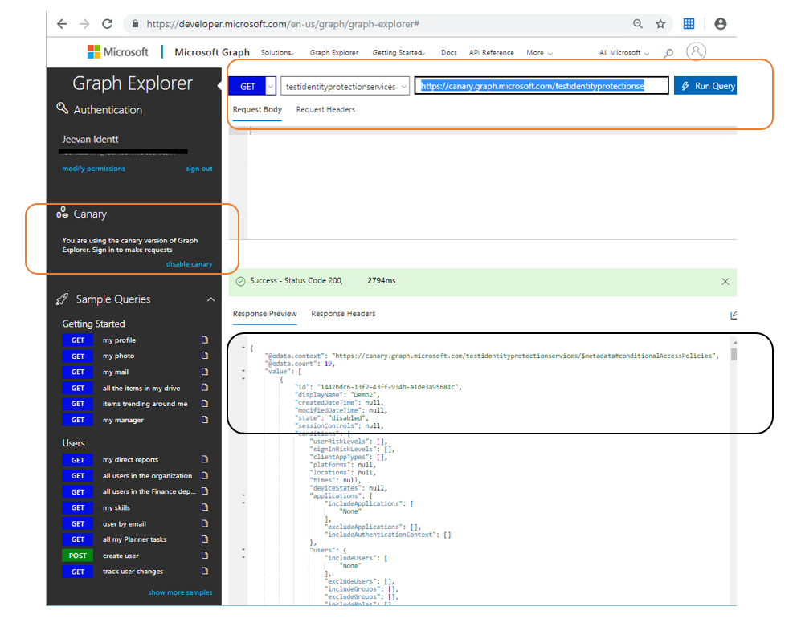

1. Save the Contents of the Response into a Text file as CAPolicyBackup.json
2. You have the backup of the CA Policies in the form of the JSON file.

**Note :**

A Conditional Access policy restore operation is essentially a new Conditional Access Policy with the configuration specified in the JSON Format. This will result in a new ID for the Conditional Access Policy. You cannot restore all the policies at once since you can only post a single policy item at a time. The option to restore all policy can be implement using API and the PowerShell to reduce the effort

***Task 2: Restoring a CA Policy***

1. From the previously backed up file Identify the CA Policy to be restored, the file is in JSON format you should be able to open this in any Text Editor or Browser.
2. Below is the example of a Conditional Access Policy

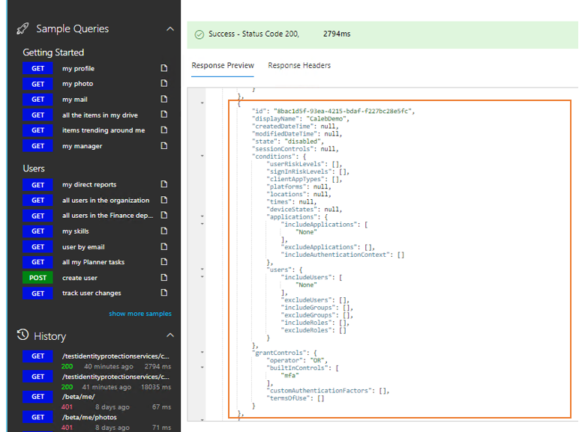

1. Prep the Policy for the Import

**3a. Extract the Policy from the Backup**

**Below is the sample extract**

{

"id": "8bac1d5f-93ea-4215-bdaf-f227bc28e5fc",

"displayName": "CalebDemo",

"createdDateTime": null,

"modifiedDateTime": null,

"state": "disabled",

"sessionControls": null,

"conditions": {

"userRiskLevels": [ ],

"signInRiskLevels": [ ],

"clientAppTypes": [ ],

"platforms": null,

"locations": null,

"times": null,

"deviceStates": null,

"applications": {

"includeApplications": ["None" ],

"excludeApplications": [ ],

"includeAuthenticationContext": [ ]

},

"users": {

"includeUsers": ["None"],

"excludeUsers": [ ],

"includeGroups": [ ],

"excludeGroups": [ ],

"includeRoles": [ ],

"excludeRoles": [ ]

}

},

"grantControls": {

"operator": "OR",

"builtInControls": [

"mfa"

],

"customAuthenticationFactors": [

],

"termsOfUse": [

]

}

}

3b. We Need to remove 3 Fields while preserving the entire policy

* **id**
* **createdDateTime**
* **modifiedDateTime**

Below is the example of the above policy being prepped for restore.

{

"displayName": "CalebDemo",

"state": "disabled",

"sessionControls": null,

"conditions": {

"userRiskLevels": [ ],

"signInRiskLevels": [ ],

"clientAppTypes": [ ],

"platforms": null,

"locations": null,

"times": null,

"deviceStates": null,

"applications": {

"includeApplications": ["None" ],

"excludeApplications": [ ],

"includeAuthenticationContext": [ ]

},

"users": {

"includeUsers": ["None"],

"excludeUsers": [ ],

"includeGroups": [ ],

"excludeGroups": [ ],

"includeRoles": [ ],

"excludeRoles": [ ]

}

},

"grantControls": {

"operator": "OR",

"builtInControls": [

"mfa"

],

"customAuthenticationFactors": [

],

"termsOfUse": [

]

}

}

4. Perform a **POST** Operation with above Policy. Copy the content of the Policy in the **RequestBody** and click on **RunQuery** button

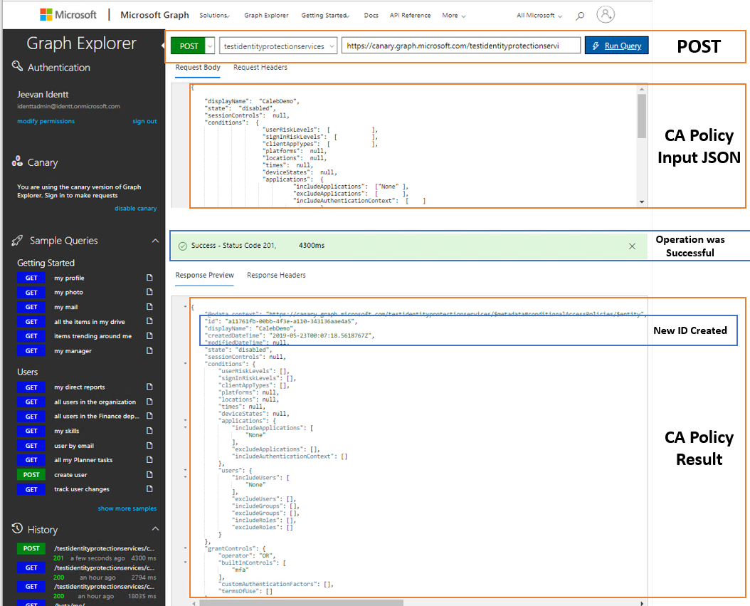

If the operation was successful you will get HTTP 201 return code and, In the response, see the CA Policy was created with the new id generated.

1. Verify in the Azure AD Conditional Access Policy Console.

**Note:** There might be a schema change soon causing some of the fields to have a different name, you might need to modify that if you have an older export of the CA Policies JSON.

The information contained in this document represents the current view of Microsoft Corporation on the issues discussed as of the date of publication. Because Microsoft must respond to changing market conditions, it should not be interpreted to be a commitment on the part of Microsoft, and Microsoft cannot guarantee the accuracy of any information presented after the date of publication.

MICROSOFT MAKES NO WARRANTIES, EXPRESS, IMPLIED OR STATUTORY, AS TO THE INFORMATION IN THIS DOCUMENT.

Complying with all applicable copyright laws is the responsibility of the user. Without limiting the rights under copyright, no part of this document may be reproduced, stored in or introduced into a retrieval system, or transmitted in any form or by any means (electronic, mechanical, photocopying, recording, or otherwise), or for any purpose, without the express written permission of Microsoft Corporation.

Microsoft may have patents, patent applications, trademarks, copyrights, or other intellectual property rights covering subject matter in this document. Except as expressly provided in any written license agreement from Microsoft, the furnishing of this document does not give you any license to these patents, trademarks, copyrights, or other intellectual property.

The descriptions of other companies’ products in this document, if any, are provided only as a convenience to you. Any such references should not be considered an endorsement or support by Microsoft. Microsoft cannot guarantee their accuracy, and the products may change over time. Also, the descriptions are intended as brief highlights to aid understanding, rather than as thorough coverage. For authoritative descriptions of these products, please consult their respective manufacturers.

© 2018 Microsoft Corporation. All rights reserved. Any use or distribution of these materials without express authorization of Microsoft Corp. is strictly prohibited.

Microsoft and Windows are either registered trademarks of Microsoft Corporation in the United States and/or other countries.

The names of actual companies and products mentioned herein may be the trademarks of their respective owners.